July 28, 2022

Tree Clemonds
Providence Housing Development Corp.
1150 Buffalo Road
Rochester, NY 14624

Dear Ms. Clemonds,

Family Promise of Greater Rochester is writing to offer support to the Door of Hope rapid rehousing program funded by the American Rescue Plan Act.

When eligible, we will offer the following services to program participants at Door of Hope between January 2023 and December 2026:

- Shelter Program for families with children 18 years of age or younger. Family Promise of Greater Rochester receives no reimbursement from the Department of Human Services for the shelter stay. Shelter placement is prioritized for those families who don’t quality for assistance (TANF) through the Department of Human Services, are employed or in receipt of SSI/SSD benefits, and families who have “timed out” or are sanctioned from the DHS system.

In addition, if we receive calls from persons fleeing domestic violence or human trafficking and they require housing, we will contact Door of Hope at Providence Housing for availability and eligibility.

We look forward to working with you.

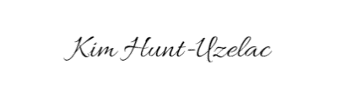
Kim Hunt-Uzelac, LMSW
Executive Director, Family Promise of Greater Rochester

